**EGR 302 – Engineering Design and Documentation**

**Deliverable 1: Problem Definition and Needs Identification**

Team Name: RPMs

Team Members: Dylan Shanahan

Jordan Ziegler

Tim Decious

Josh Hemsley

Brian Ungermann

Austin Hulen

Client’s Name: Dr. Xu

Version: 3

Date: 1/17/2014

* 1. Initial Problem Statement

The project is to build a rotating LED wand that can be used to signal for help or advertise for a company. Dr. Xu needs a wand that can display words or pictures in color. It should also operate on battery so that it can be easily transported. The client also wants it to be controlled by a smartphone or tablet.

* 1. Client Interview

|  |  |  |
| --- | --- | --- |
| Question | Answer | Interpretation |
| How durable should the product be? | We don't need to make it military scale. Just focus on southern california (temperatures from 30-120 degrees. | The product doesn't need to be Ironclad, but it should be able to sit outside for a while |
| Should it be magnetic on the bottom? | Yes, or use a heavy battery or something that will keep it from trembling when on top of a car. | It doesn't matter how it stays still, just that it does. |
| How long should the battery last? | One full battery should last 1 full hour running or around 4 months while not in use | Battery should last an hour in run mode, 3-4 months while off. |
| Is weight an issue we should focus on? | It needs to be easily portable in the trunk. So overall, we determine the final weight but it shouldn't be too heavy. The base should be relatively heavier so it won't shake or wobble. | It should be light enough to be portable. |
| Should it have a pretty easy assembly? | Yes, easily assembly is a priority. It needs to be easy to take apart and put together. | The Product needs to be able to be assembled and disassembled with ease. |
| Does it need to have safety features? | We need to look into this ourselves. | Yes, but it's the team's job to come up with them. |
| Should we put a set timer in the product? | Yes it would be nice to have and is pretty easy to do. | There should be a timer on the device. |
| When displaying the words on the LED do you want it to be seen from one position or multiple positions? | In the end, it's up to use. We also need to consider how big the words should be.Typical scenario should be a car breaks down on the side of the road and they get out our device and put it on top of their car asking for help. | Size and viewability is up for discussion by the team |
| How far away should you be able to see the words from? | We need to research this ourselves. (he mentioned something about 50 feet.) | Words should be visible from the side of the road so that people can see the user needs help. |

* 1. Background Research and Relevant technology

1. Existing products and technology. Available products which may be expanded upon.
2. Sensor and motor research and control methodologies.
3. Microcontrollers and sensors
4. Mechanical structure and practical considerations
5. Wireless modules
6. Safety features
   1. Objectives Tree

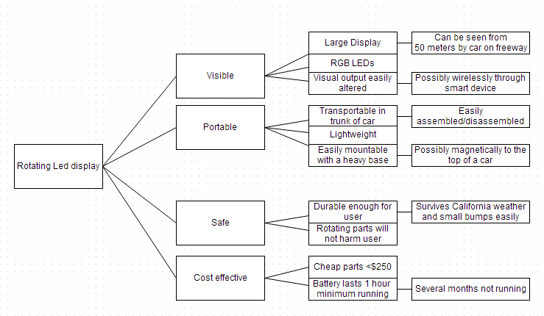

* 1. Pairwise Comparison Chart

|  |  |  |  |  |  |
| --- | --- | --- | --- | --- | --- |
| Goals | Visible | Portable | Safe | Cost Effective | Score |
| Visible | … | 0 | 1 | 1 | 2 |
| Portable | 0 | … | 1 | 0 | 1 |
| Safe | -1 | 0 | … | 0 | -1 |
| Cost Effective | -1 | -1 | 0 | … | -2 |

1.6 Problem Definition

The goal is to build a rotating LED wand that can be implemented to display pictures and words. This can be used to signal for help or advertise for a company. The device needs to operate on battery and can be disassembled and reassembled quickly and easily for transport. The project first and foremost needs to display visible words and images. Visibility from a great distance in color are the most important factors. The device needs to be easily portable. This is almost as important as the visual aspect of the design. The design also needs to be safe and cost effective. This design should be built affordably and should not harm the user.